**Lab - 5 Install and Configure File Server on Windows Server 2019**

**Lab Topology:**

**Machine Number: 1**

**Host Name**: IT2-DC01

**Role**: AD DS, DNS

**RAM**: 2 GB

**Domain**: NORTHERNCOLLEGE.LOCAL

**Machine Number: 2**

**Host Name**: IT2-FS01

**Role**: File Server

**RAM**: 2 GB

**Domain**: NORTHERNCOLLEGE.LOCAL

**Machine Number: 3**

**Host Name**: Win10-CL01

**RAM**: 2 GB

**Machine Number: 4**

**Host Name**: Win11-CL02

**RAM**: 2 GB

**Screenshot 1**: Take pictures of the Hardware configuration of all four machines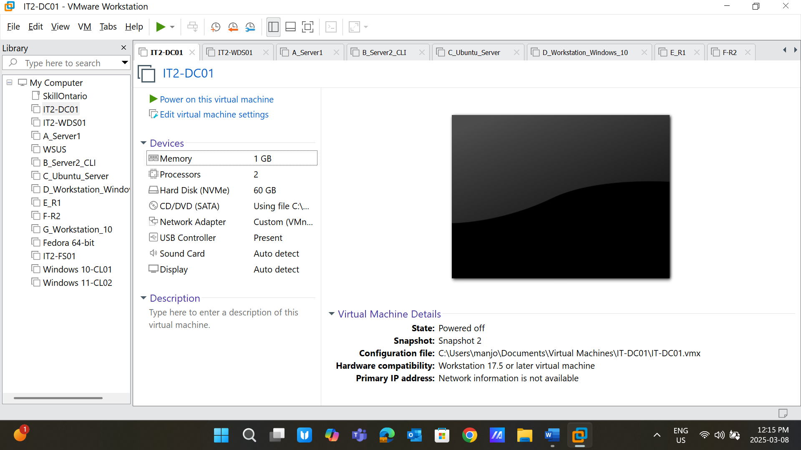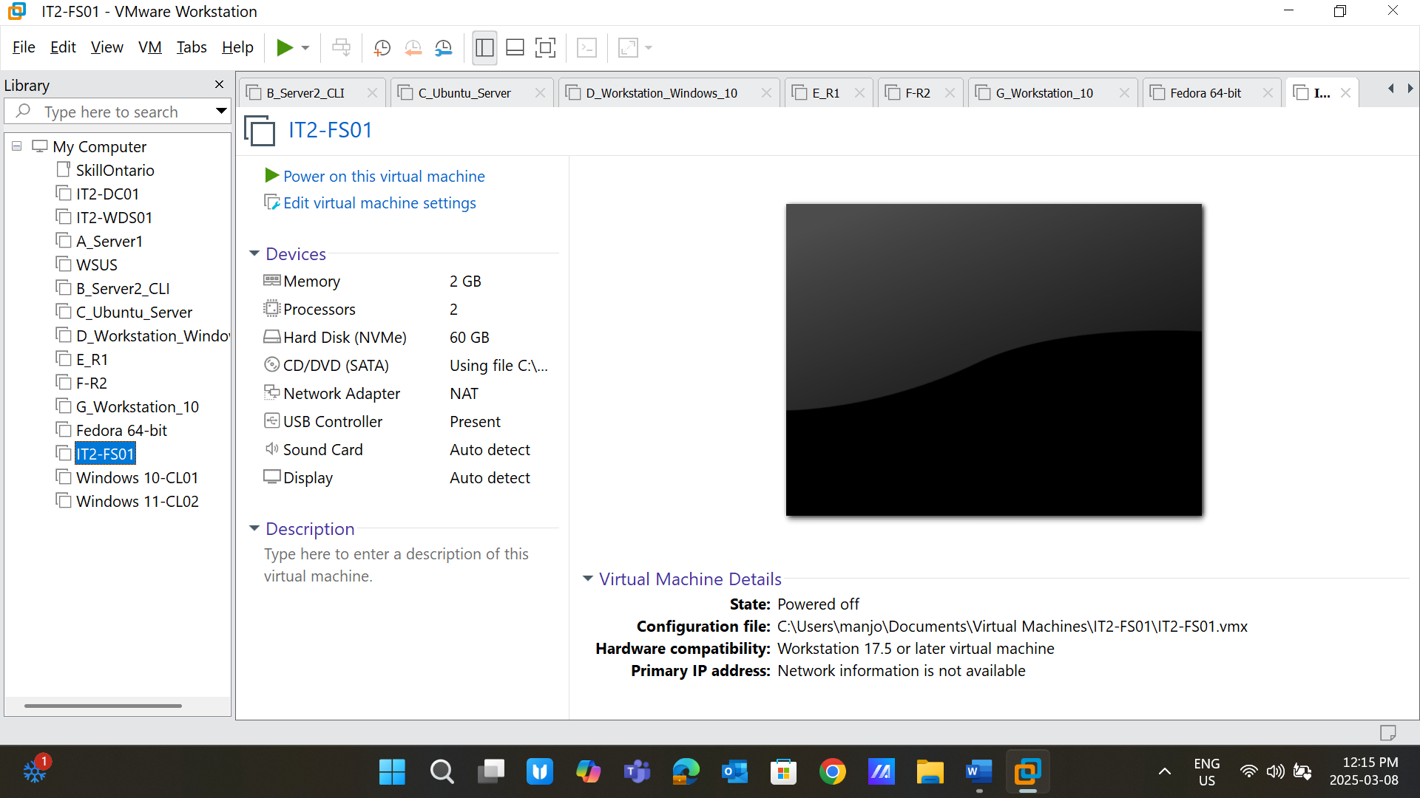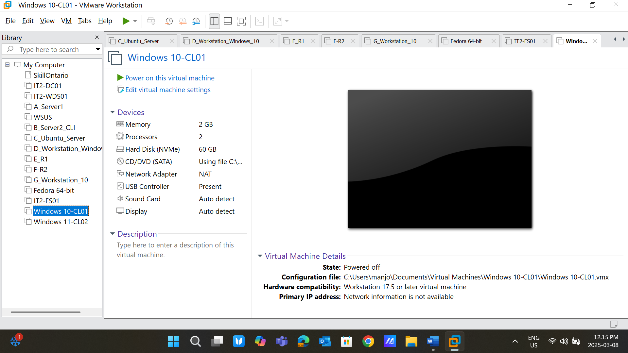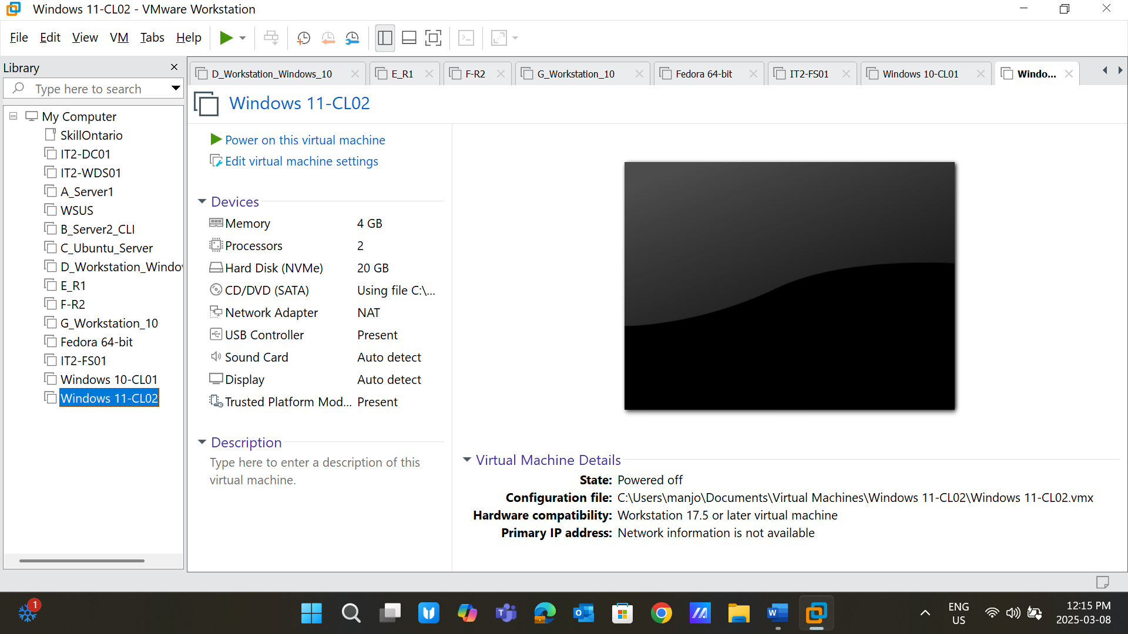

**Screenshot 2**: Create two users:

User01: Password@123

User02: Password@123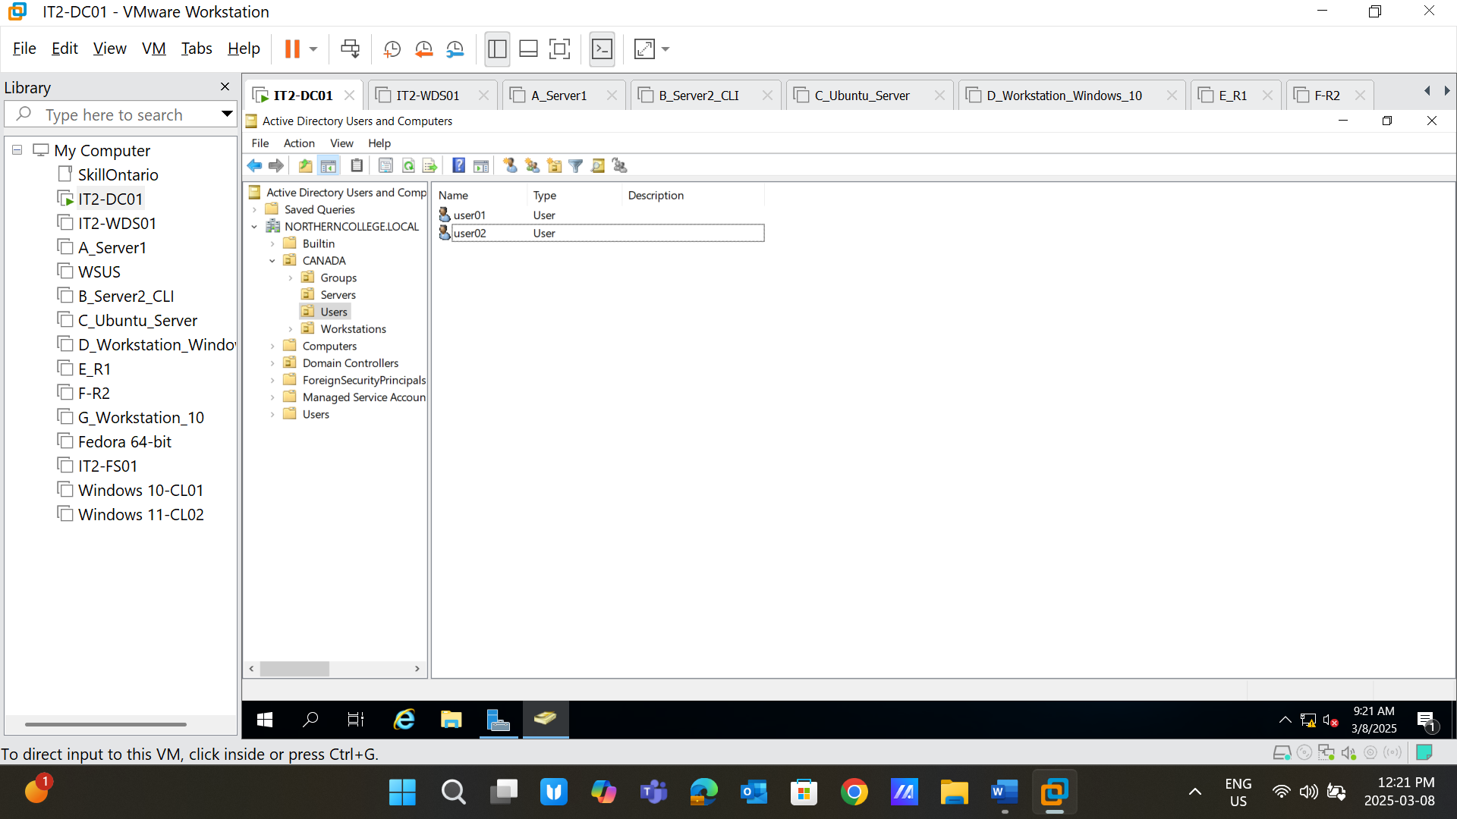

**Screenshot 3**: Log in with the created users into Windows 10 and 11 clients, respectively; take the screenshot of “whoami.” 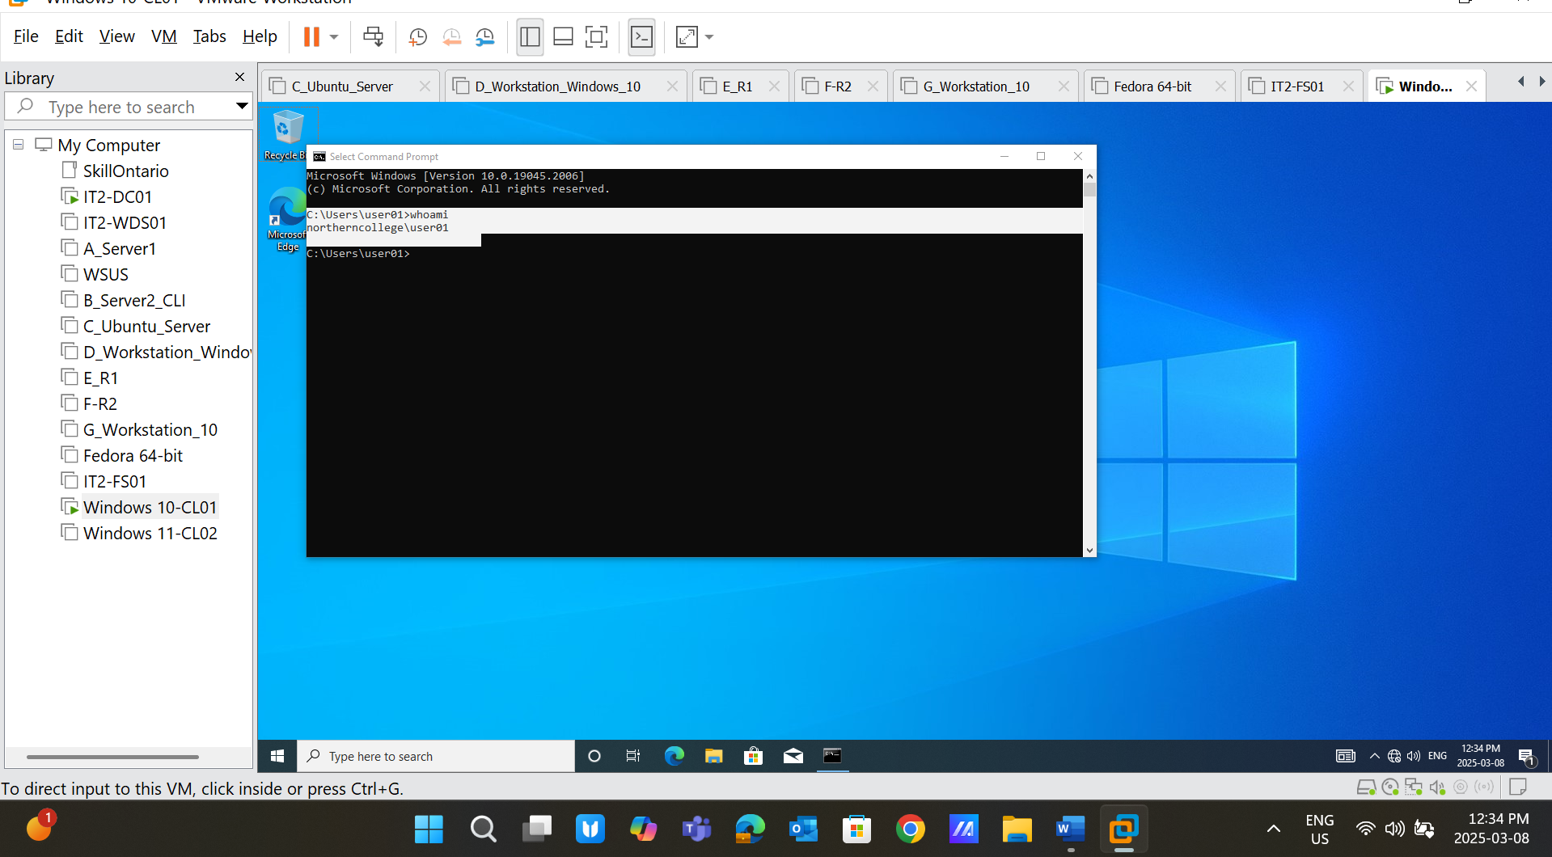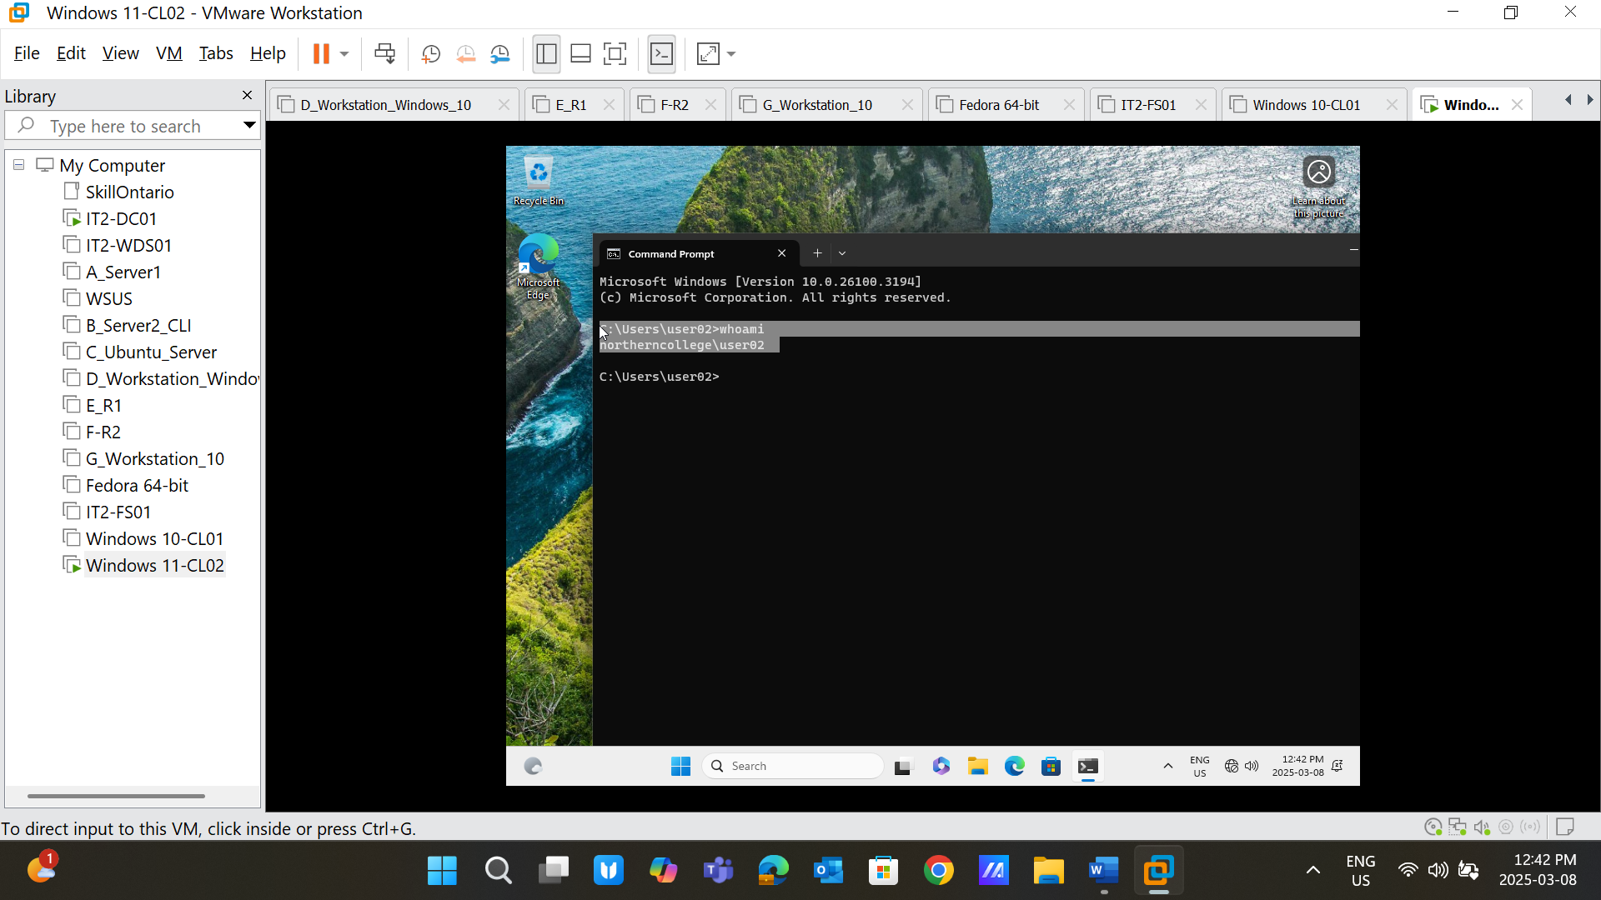

**Screenshot 4**: Put the Windows 10 and 11 clients into **OU -> Canada -> Workstations** and **IT2-FS01 to OU -> Canada -> Servers**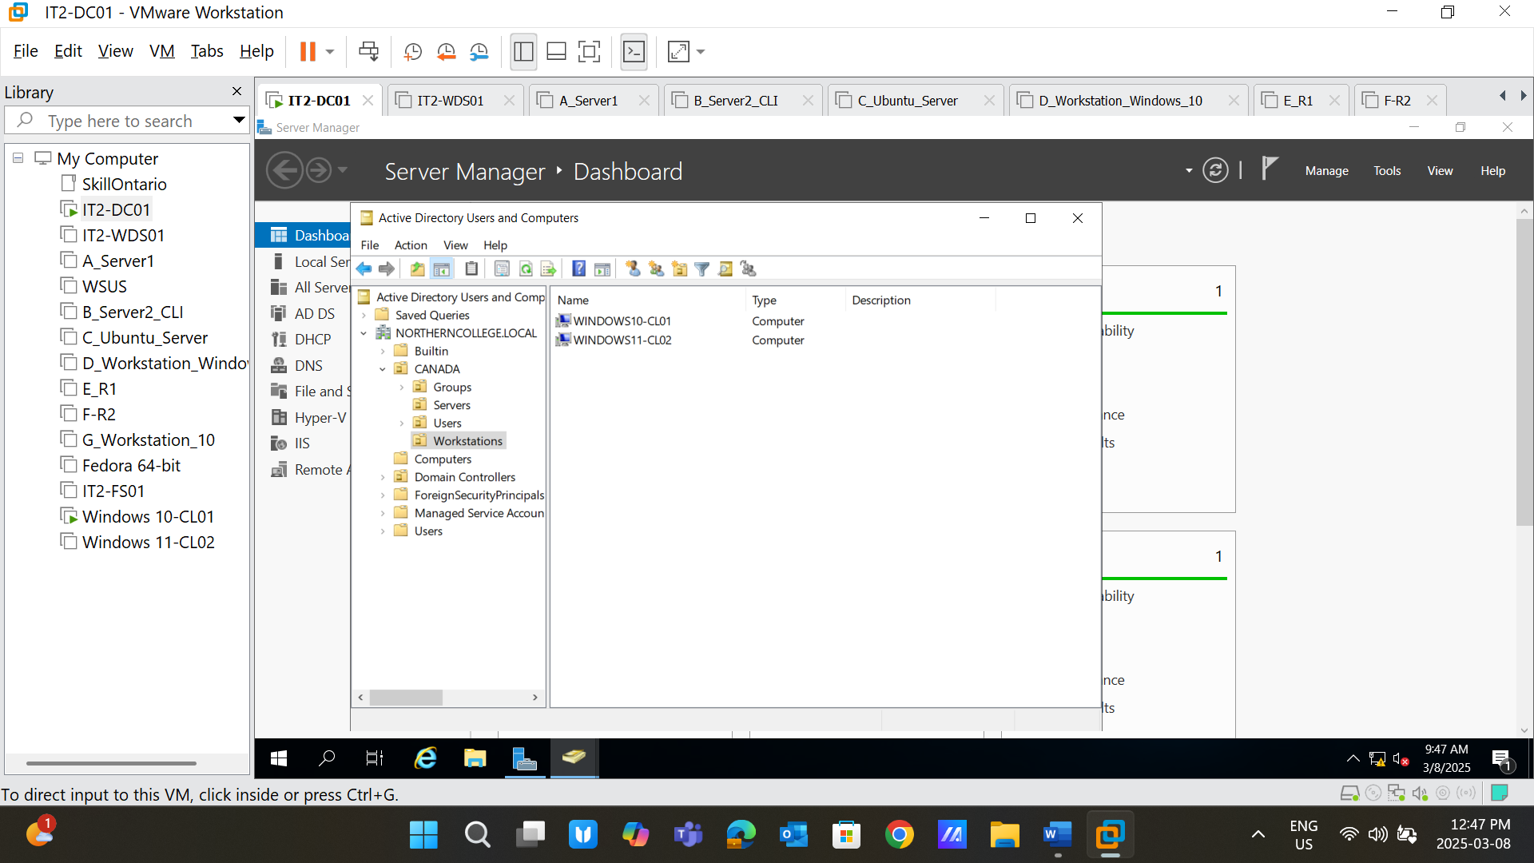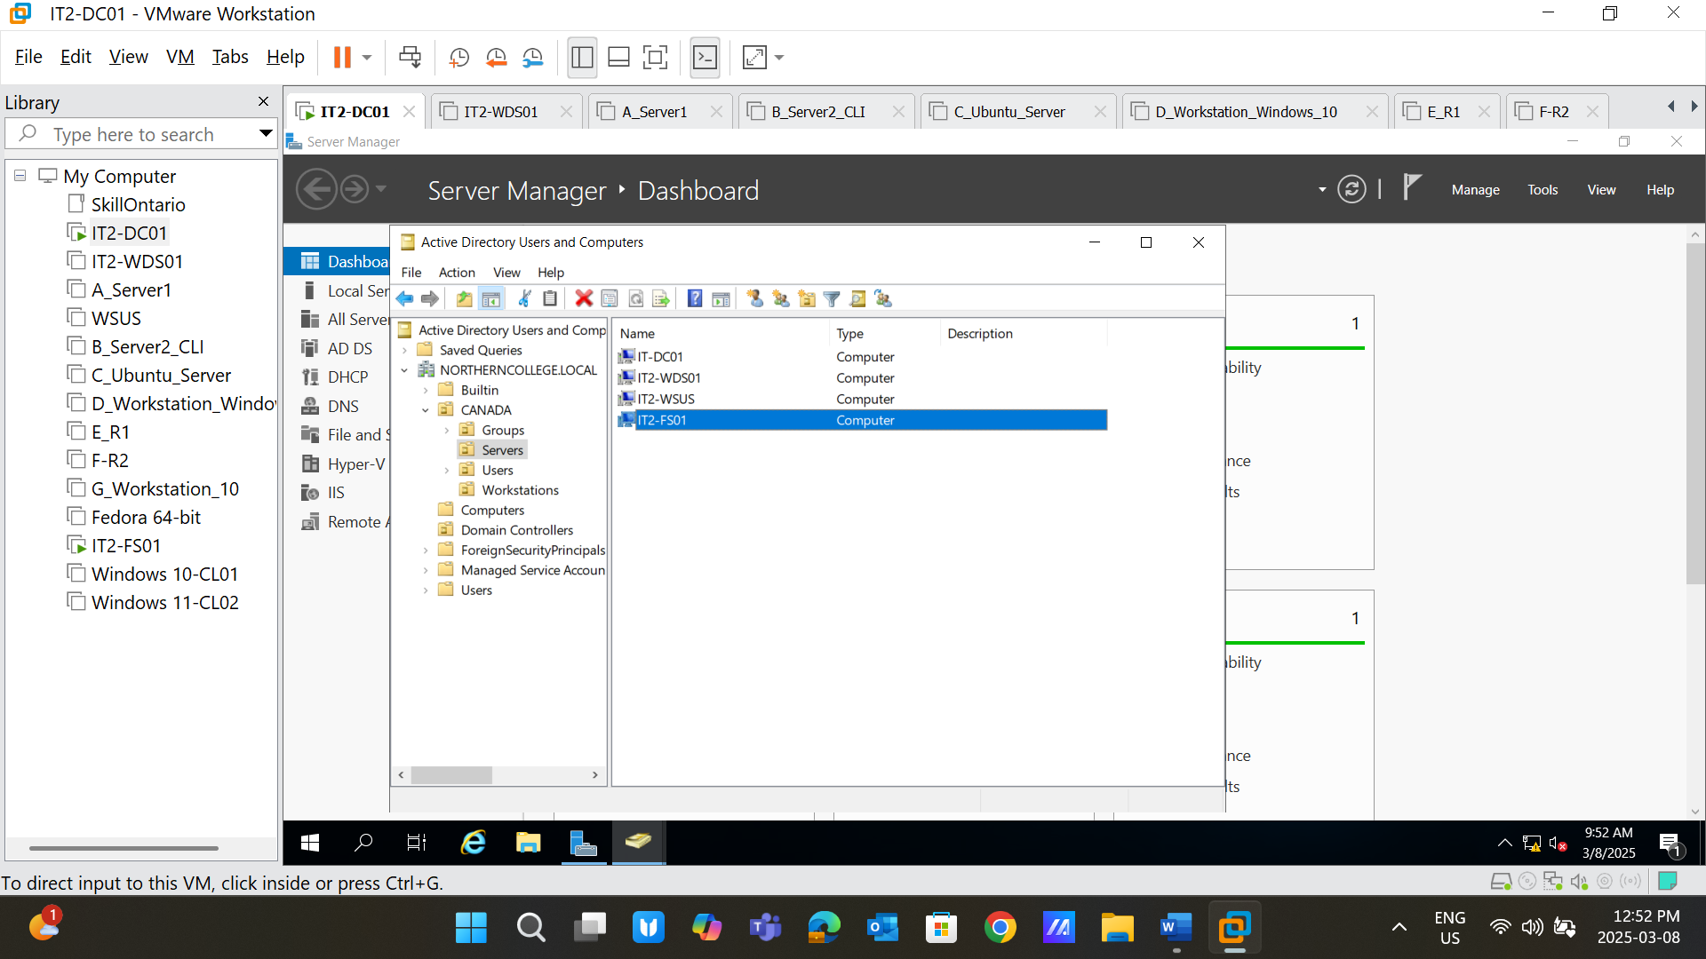

**Screenshot 5:** Define NTFS Permissions

Full Control

Modify

Read and Execute

List folder contents

Read

Write

**Screenshot 6:** Take a picture of the basic configurations – **IT2-FS01**

1. IPv4 configurations
2. IE enhanced security configuration
3. Change the Machine Name: **IT2-FS01**
4. Add Machine to the Domain: **NORTHERNCOLLEGE.LOCAL**

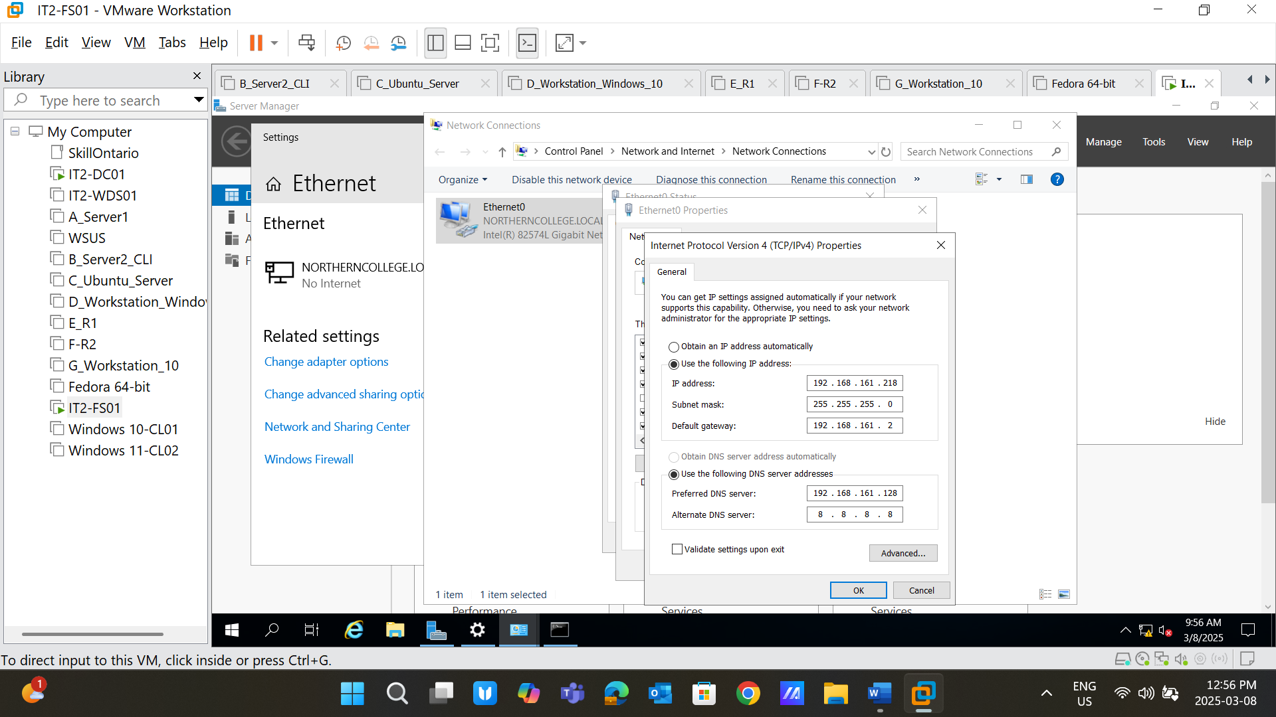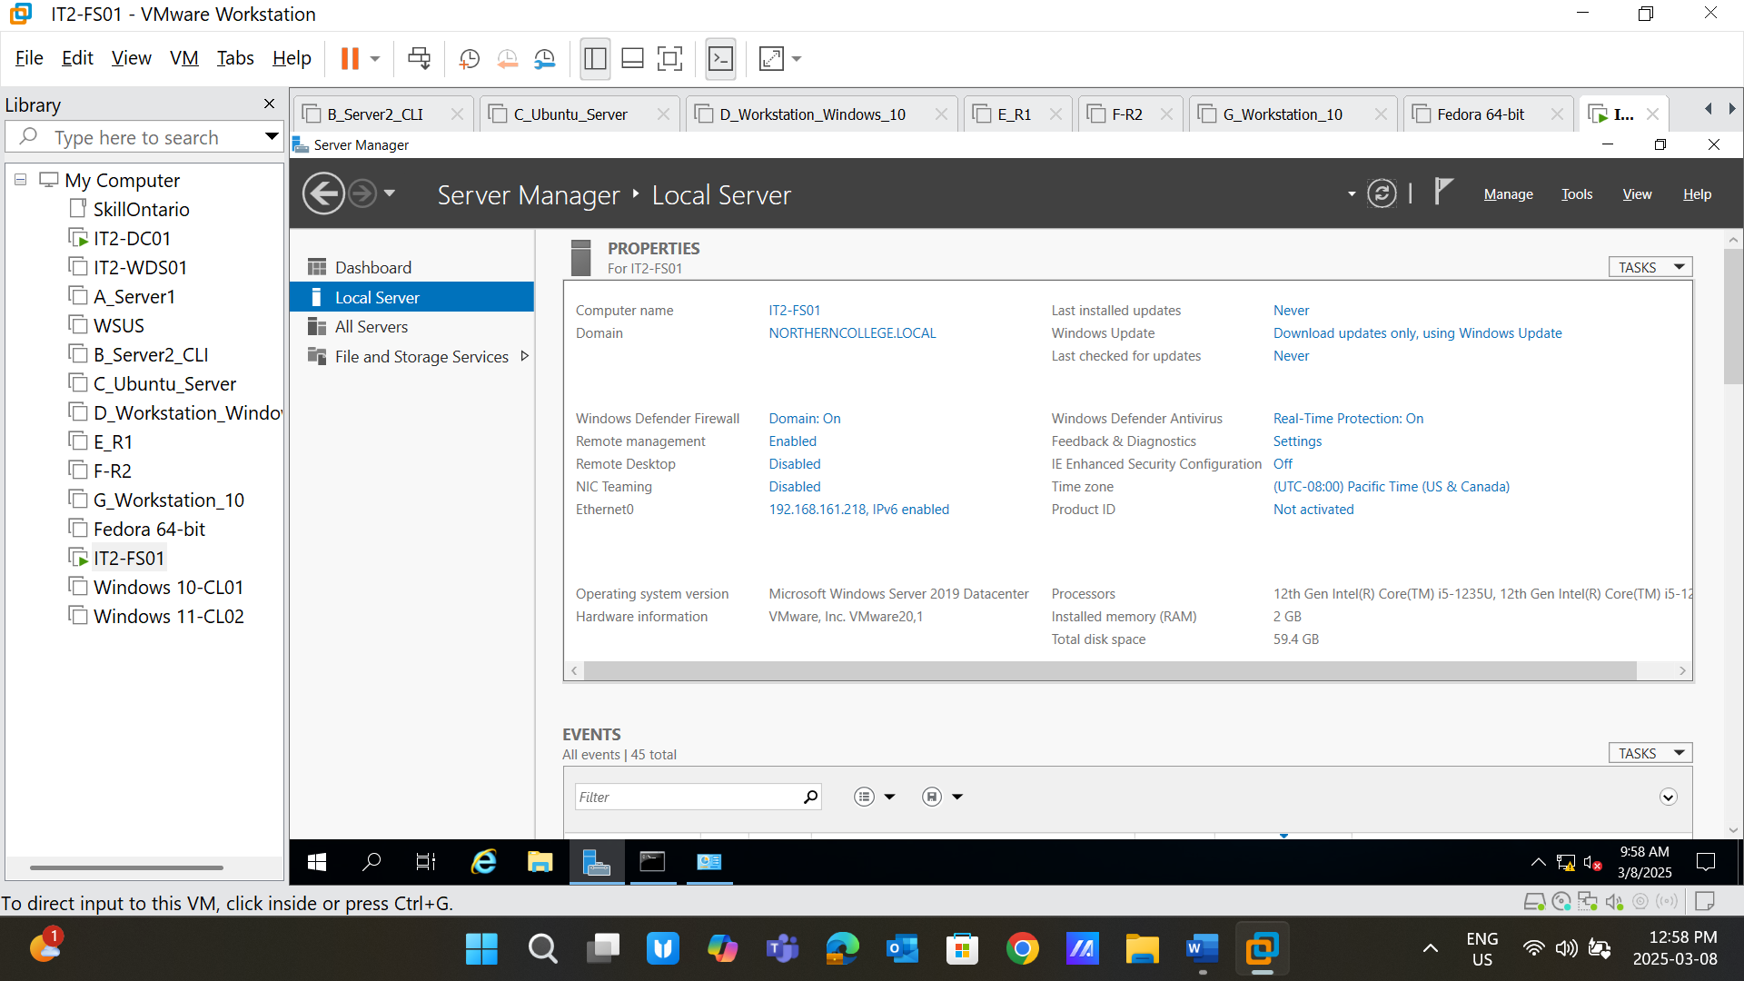

**Screenshot 7**: Create the Admin user for the File server “**fsadmin**” and login to the created account to the **IT2-FS01** machine

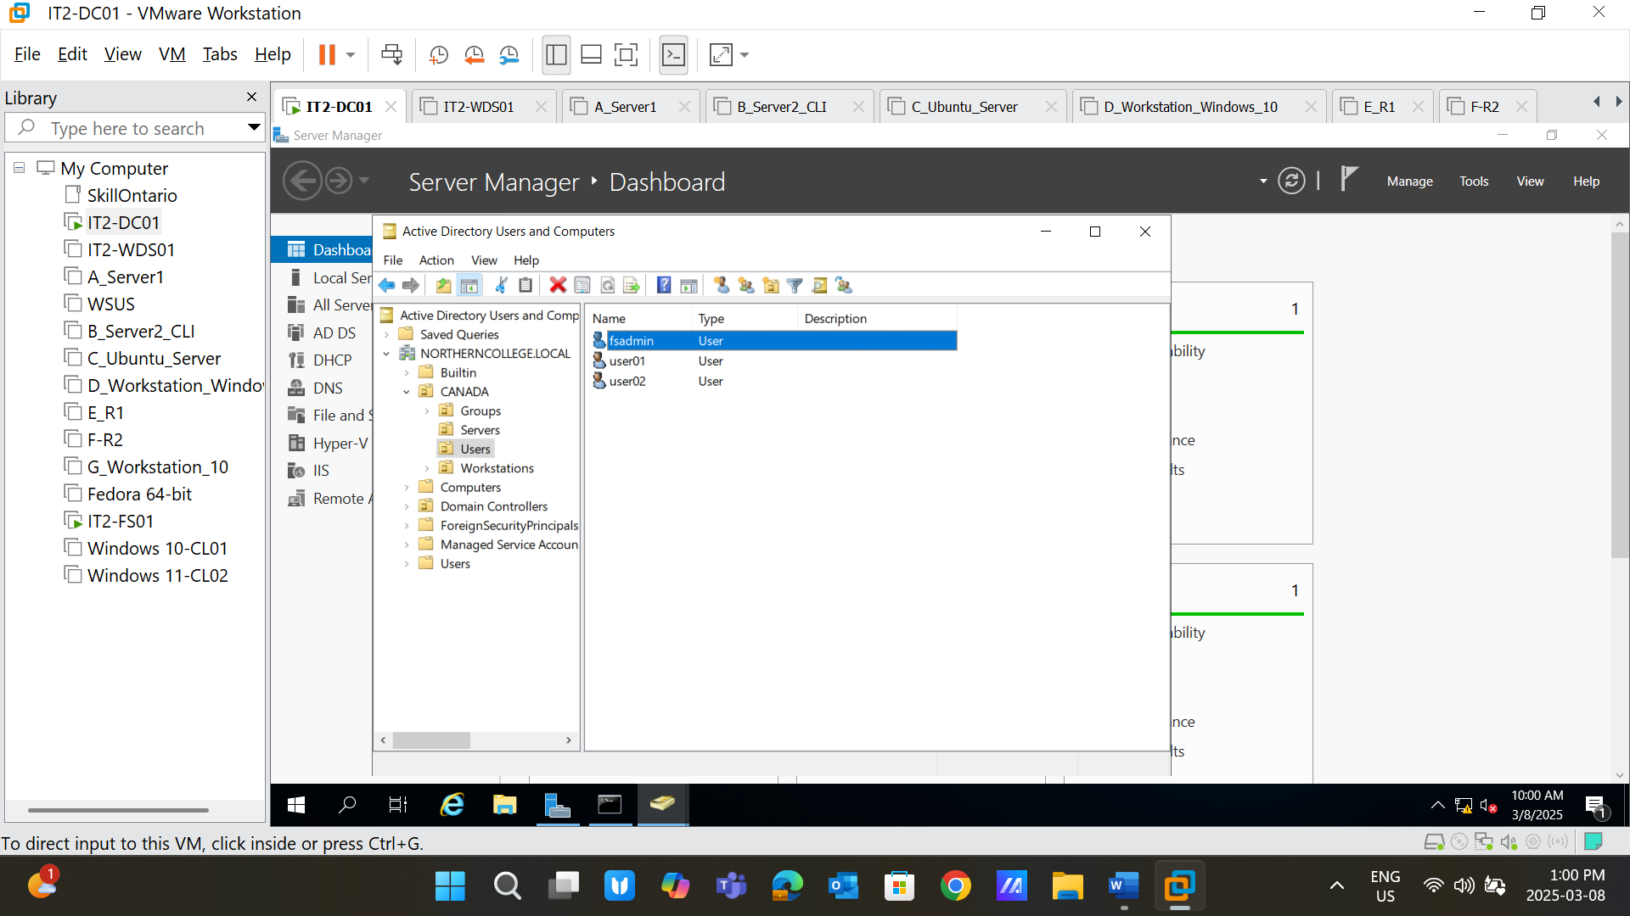

**Screenshot 8**: Give the Admin rights to the “**fsadmin”** user from the computer management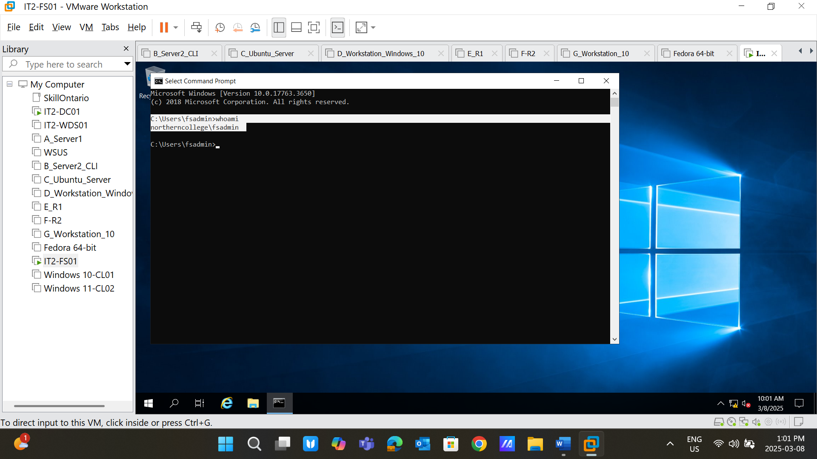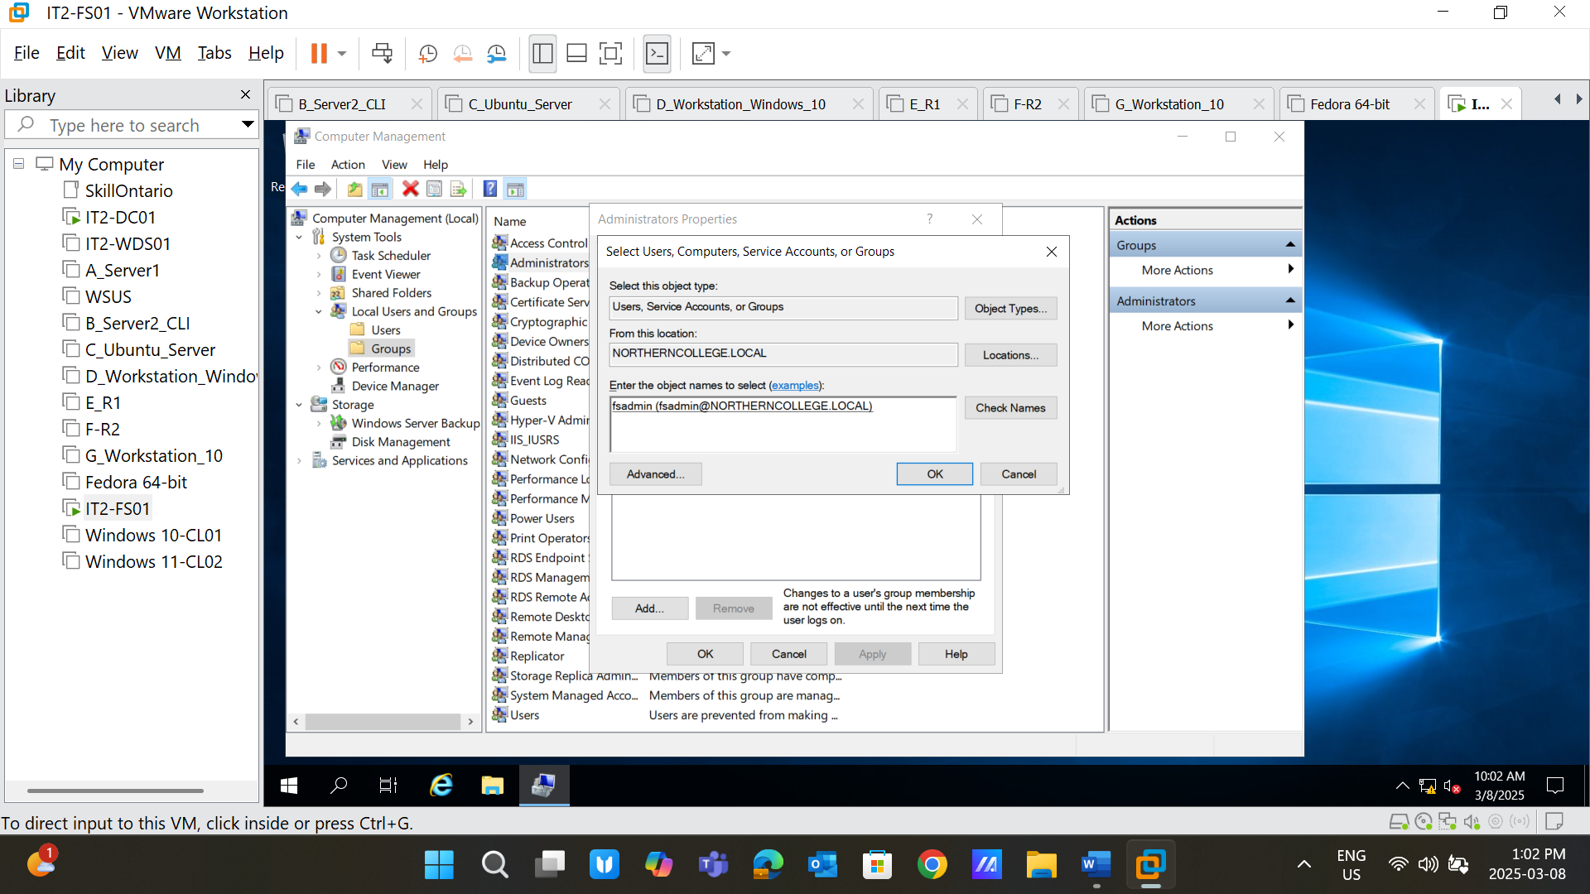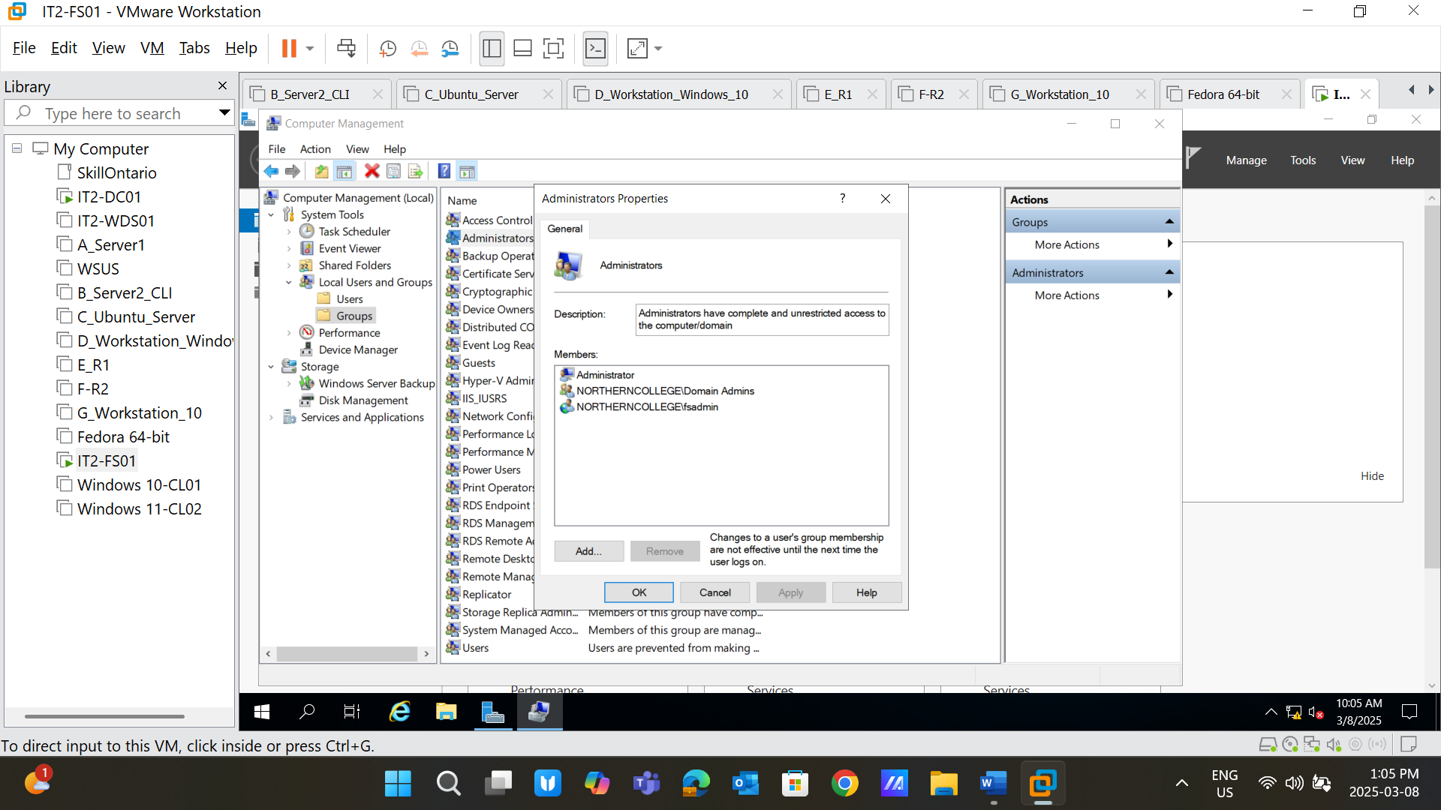

**Screenshot 9**: Install file server role (* Take the screenshot of the success page only in the last step) 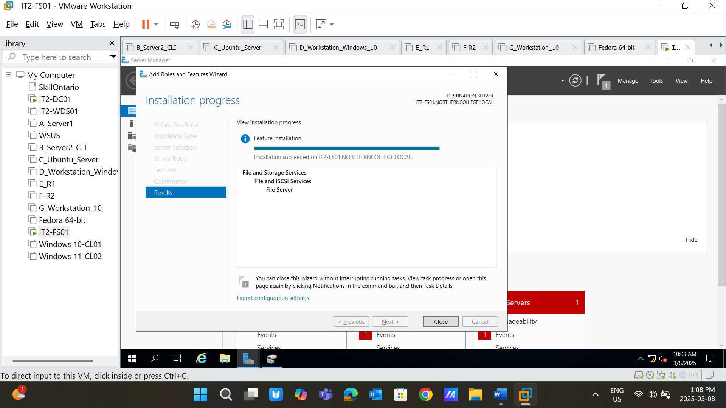

**Screenshot 10**: Create volume from the Disk management

**Volume size**: 30 GB

**Style**: GPT

**Volume Name**: Remotedrive (D:) 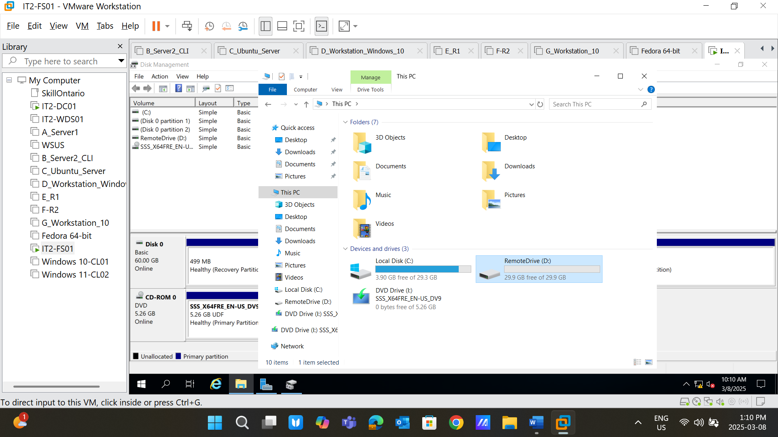

**Screenshot 11:** Configure FS

1. Go to: Server Manager-> File and Storage Services -> Shares
2. Click on: “Start the new share wizard.”
3. Select -> SMB Share – Quick
4. Select the Drive which we created before : D:
5. Share Name: **UsersData**
6. Select the “Enable access-base enumeration” and “Allow caching of share.”
7. Upon completion of all steps, take the last screenshot of the “**Results**” tab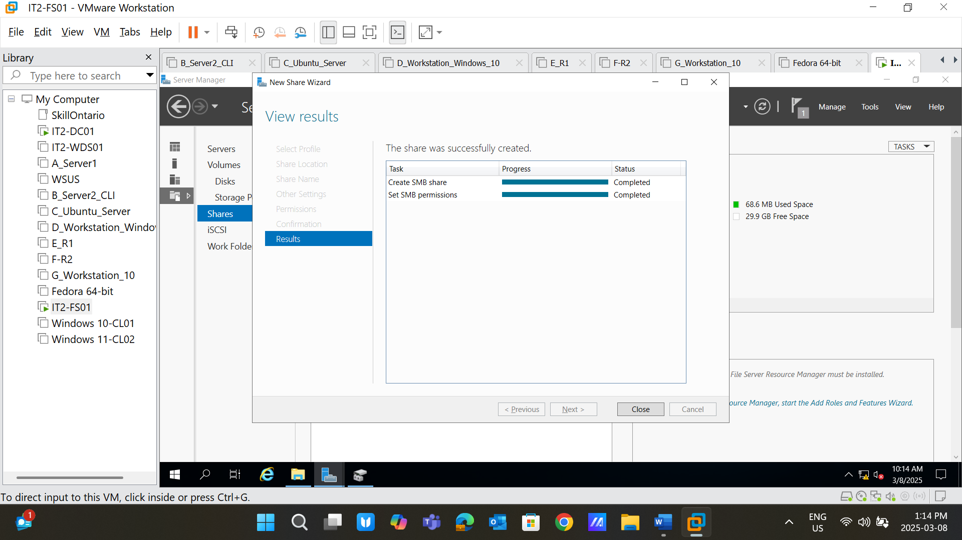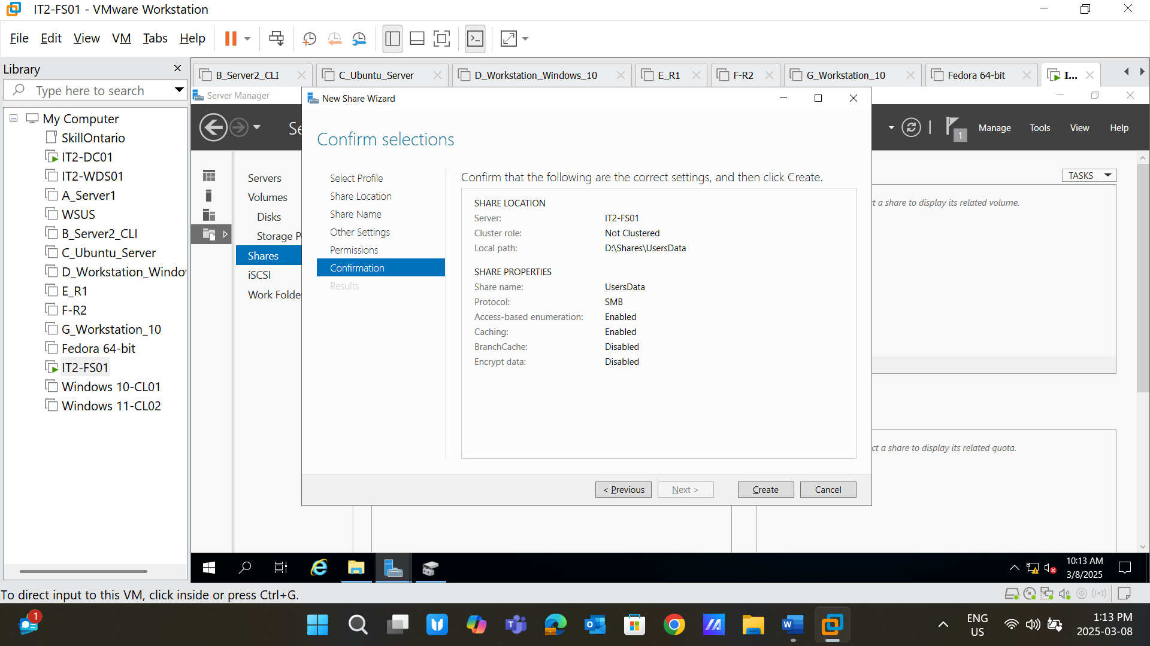

**Screenshot 12**: Configure user permissions for **user01** and **user02**

User01: Read and Write Permissions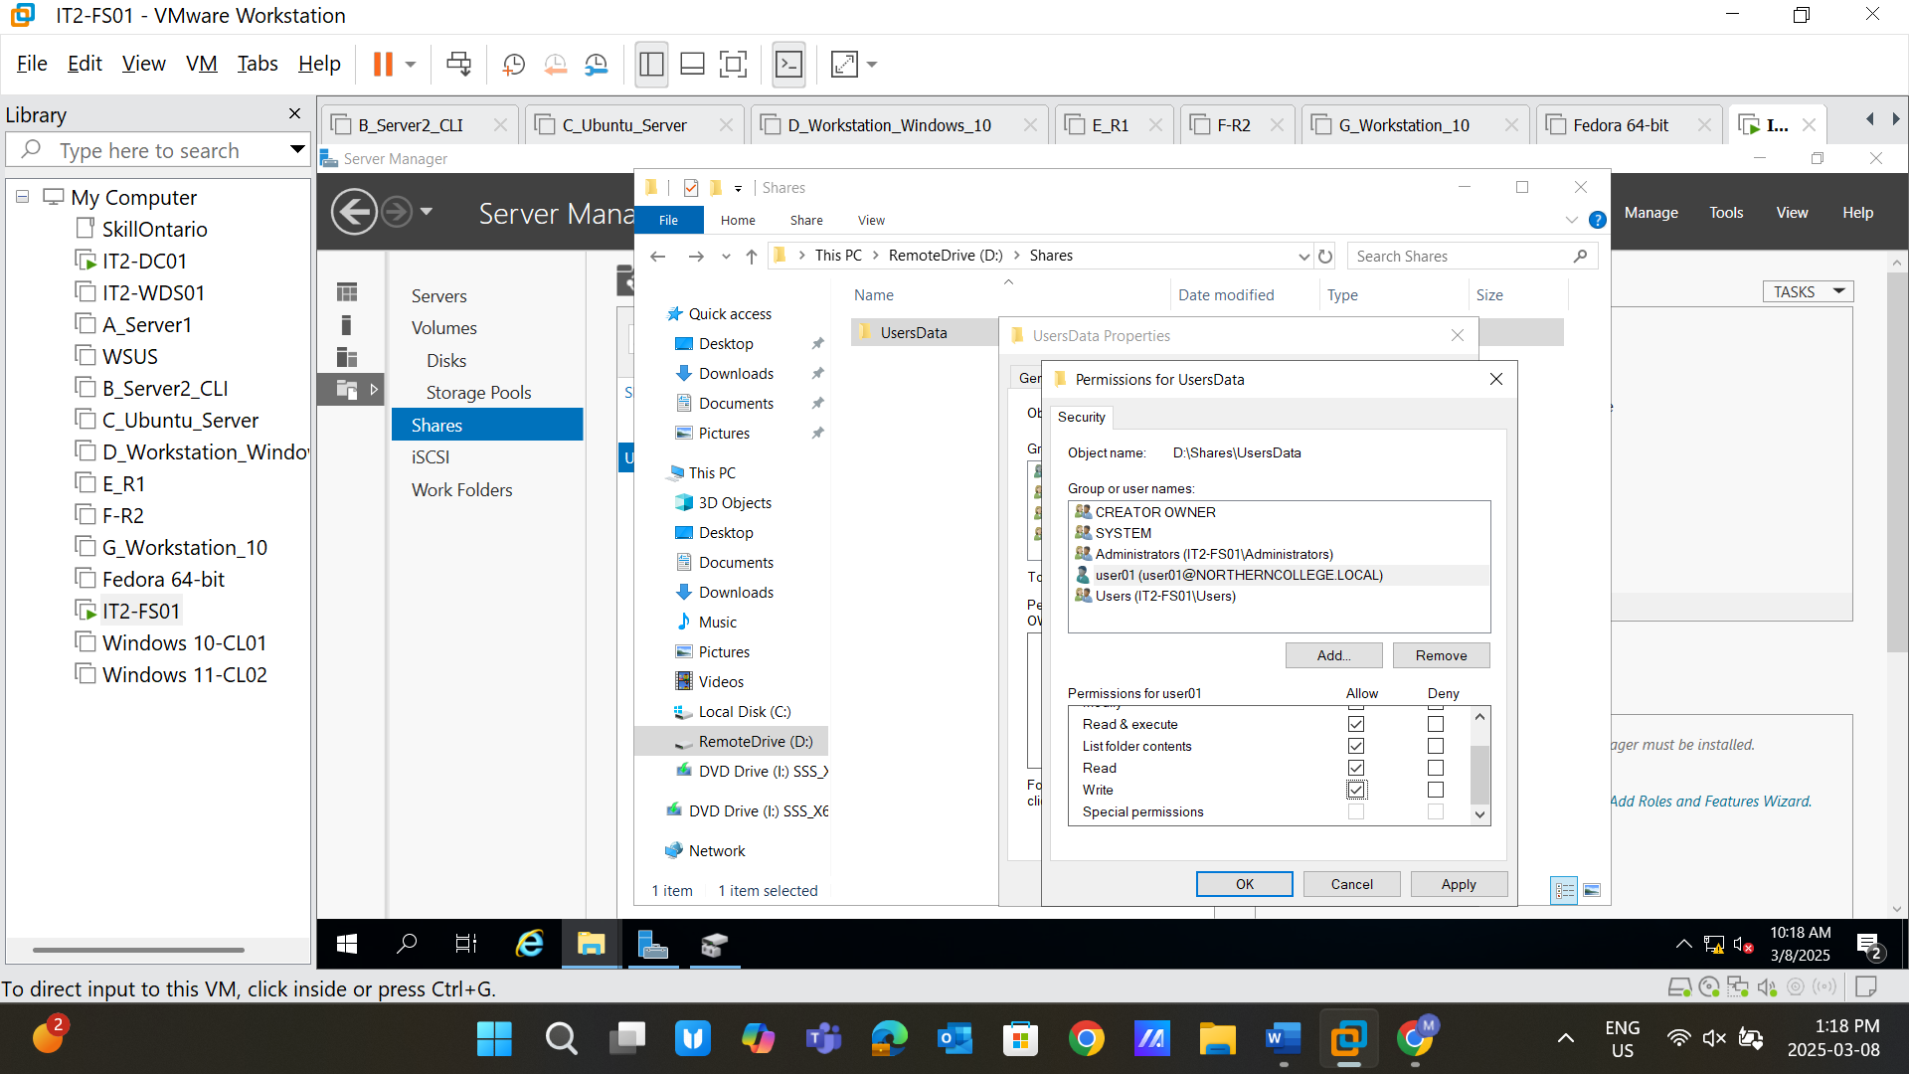

User02: Modify permissions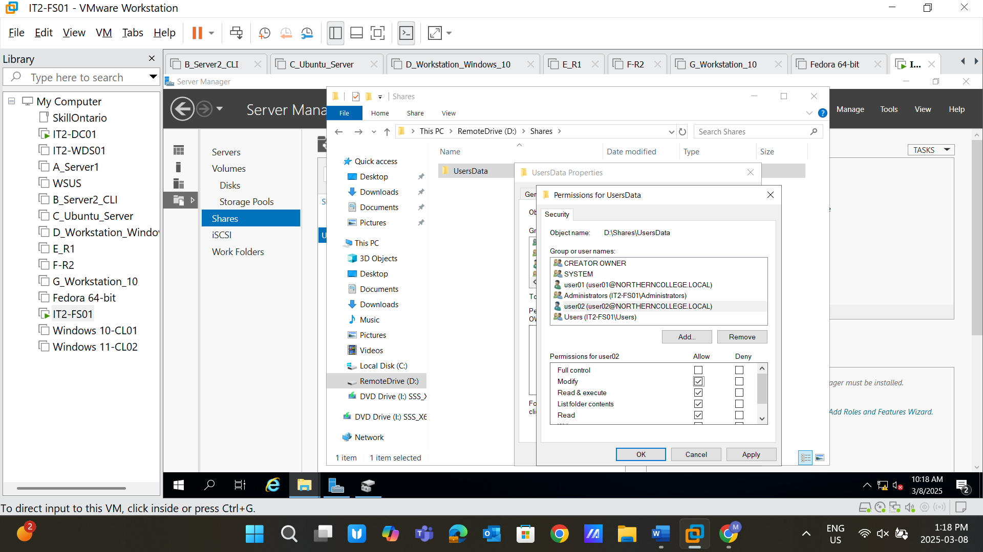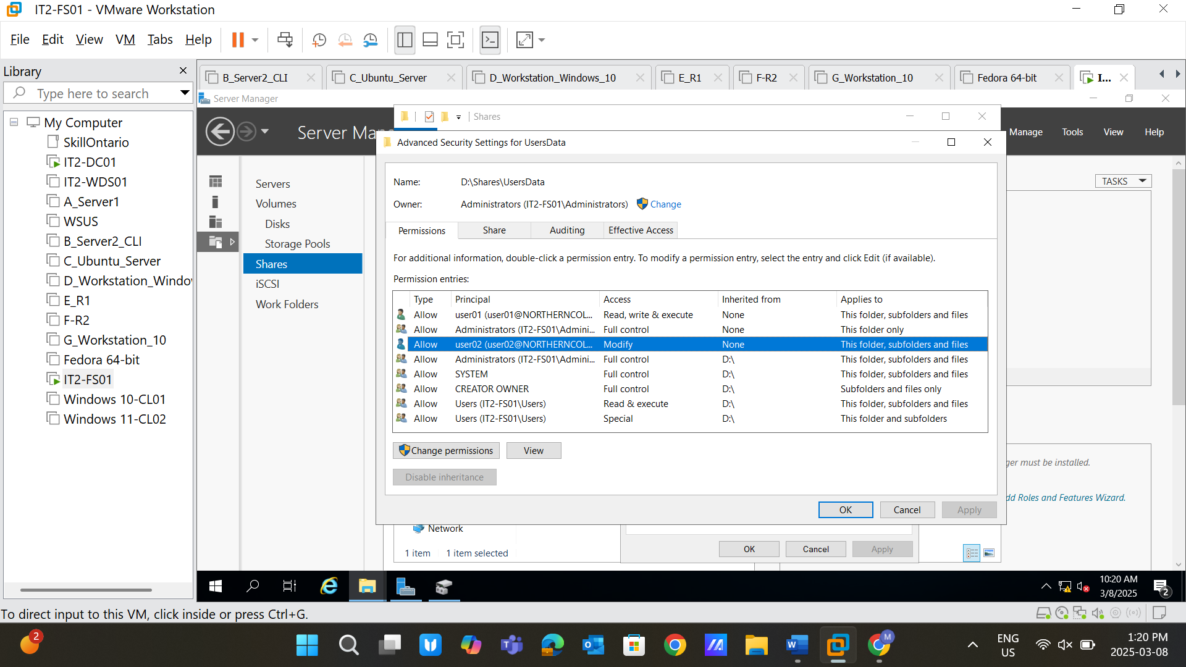

Create folders **User01** and **User02** in the D: -> Remotedrive -> UsersData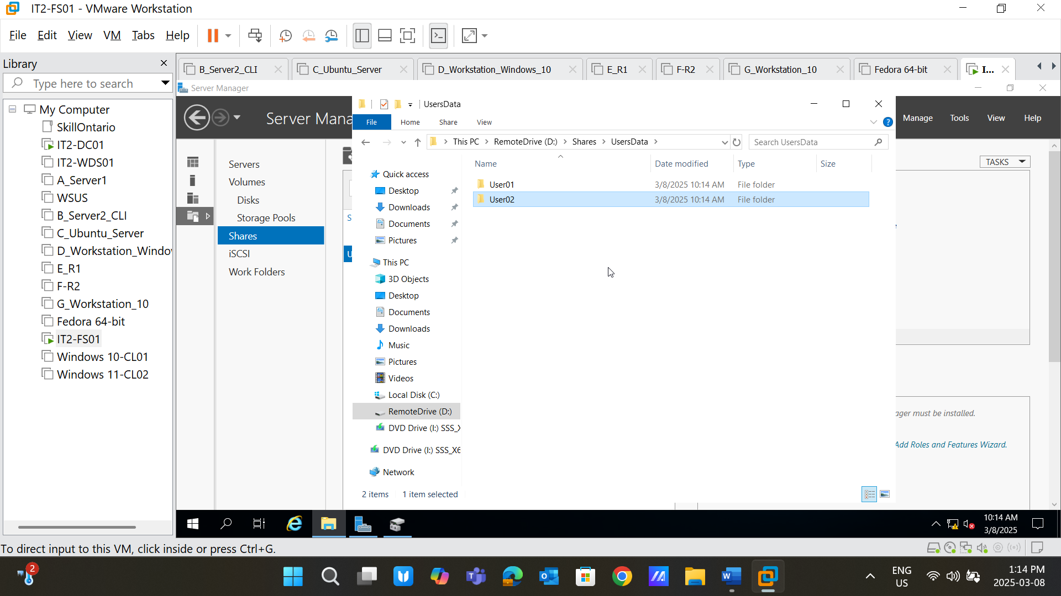

Create the file in the **User01** and **User02** folders with the same name. 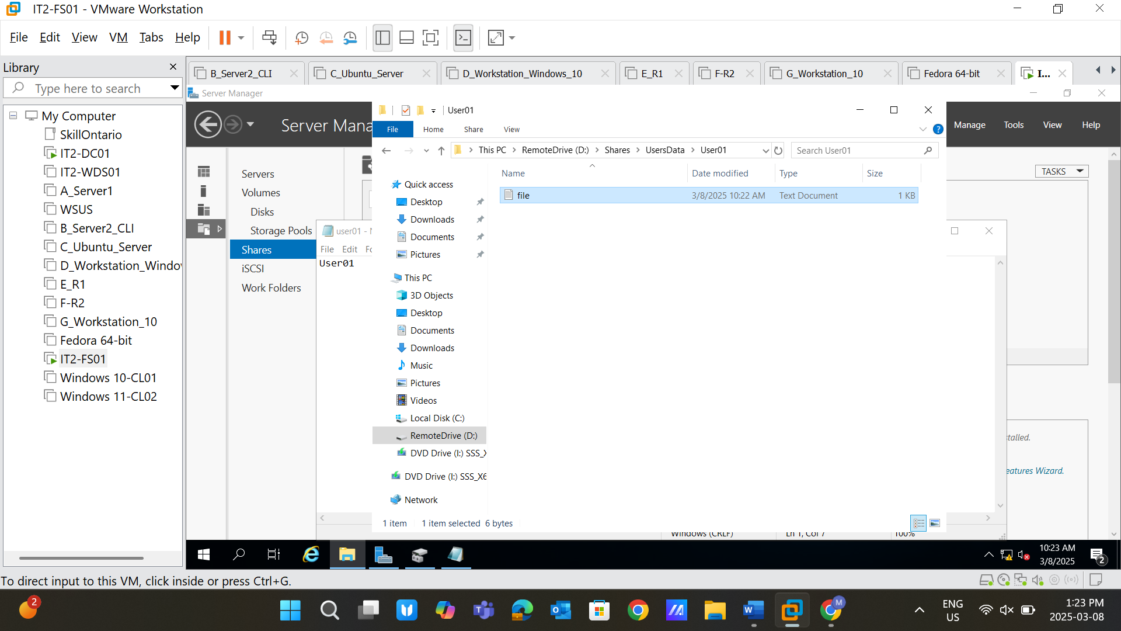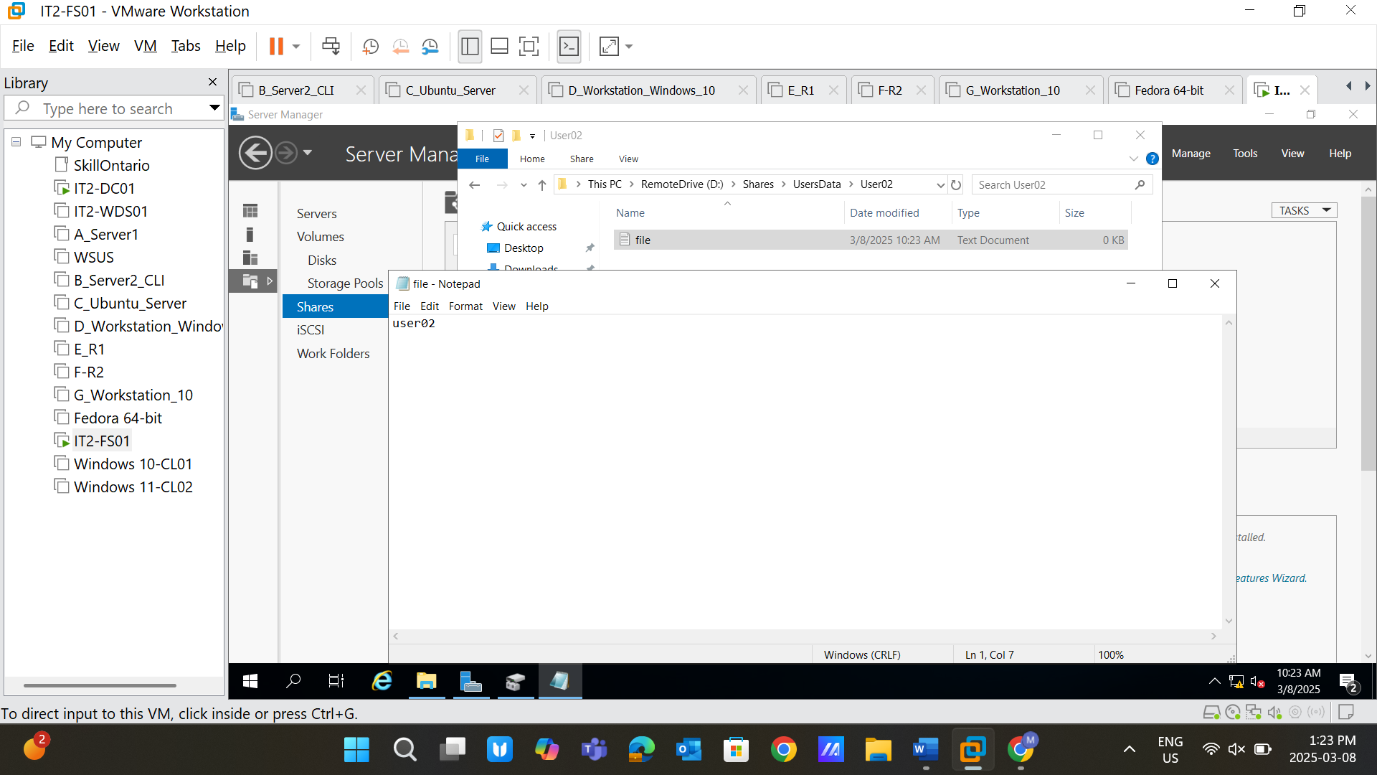

**Screenshot 13**: Verify the user's permission by performing CRUD operations on Windows 10 and 11 clients with user01 and user02 login.

**Ans: The first five screenshots belong to the Windows10-CL01 where user01 was logged in. As we know user01 has read and write permissions. The first screenshot shows that user01 can read the file that we created in the folder user01 in our main file server. Moreover, it can also be written in the “file” as it has written permission, too. Screenshot 2 is an example of that. The third screenshot shows that user01 tried to delete “file,’ but he was unsuccessful as he does not have permission to delete the file. The last two screenshots show that user01 created a new file, “file2,” as user01 was the author, he can delete the file.**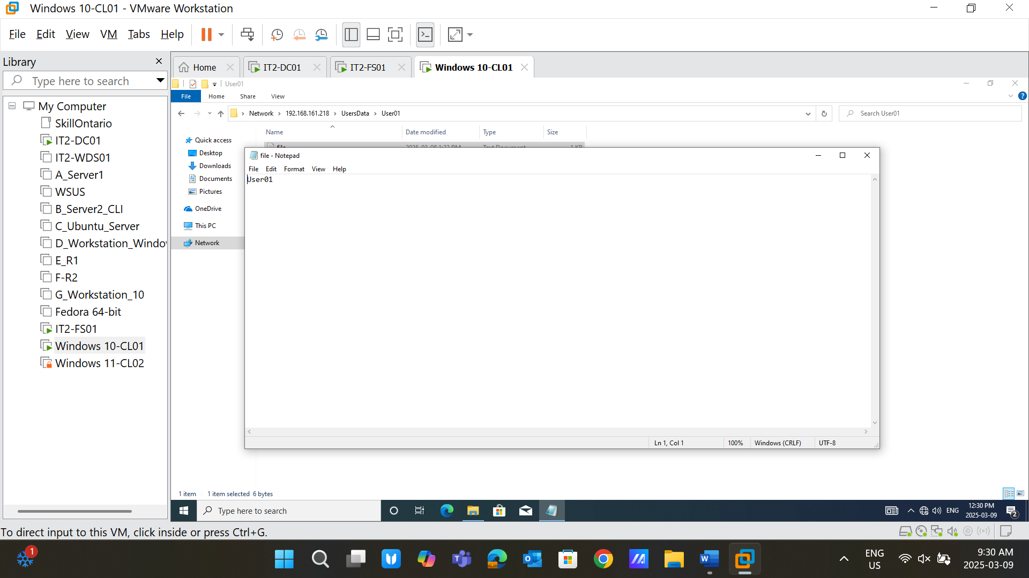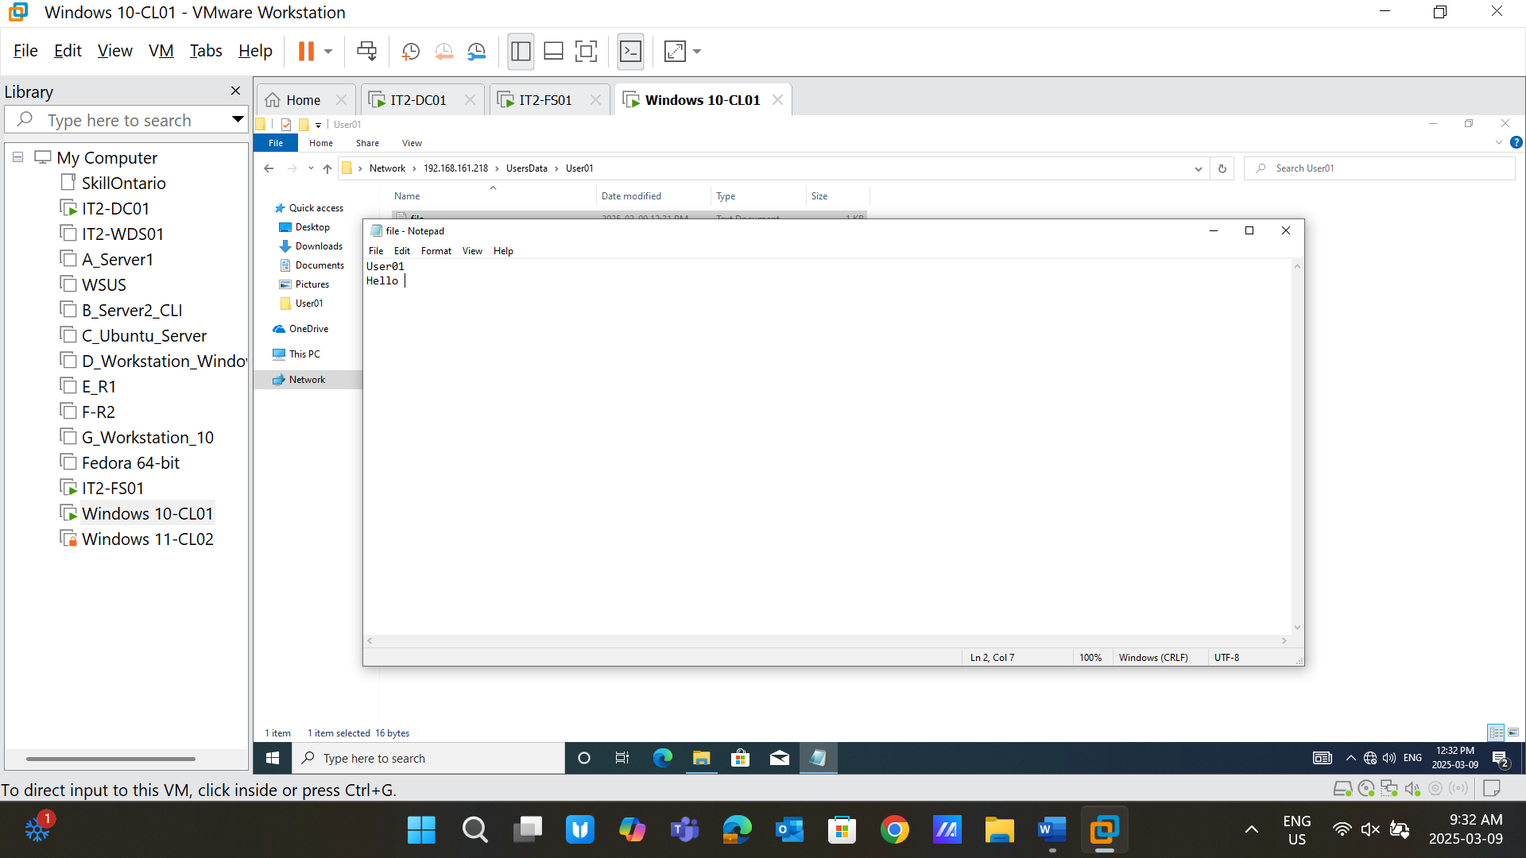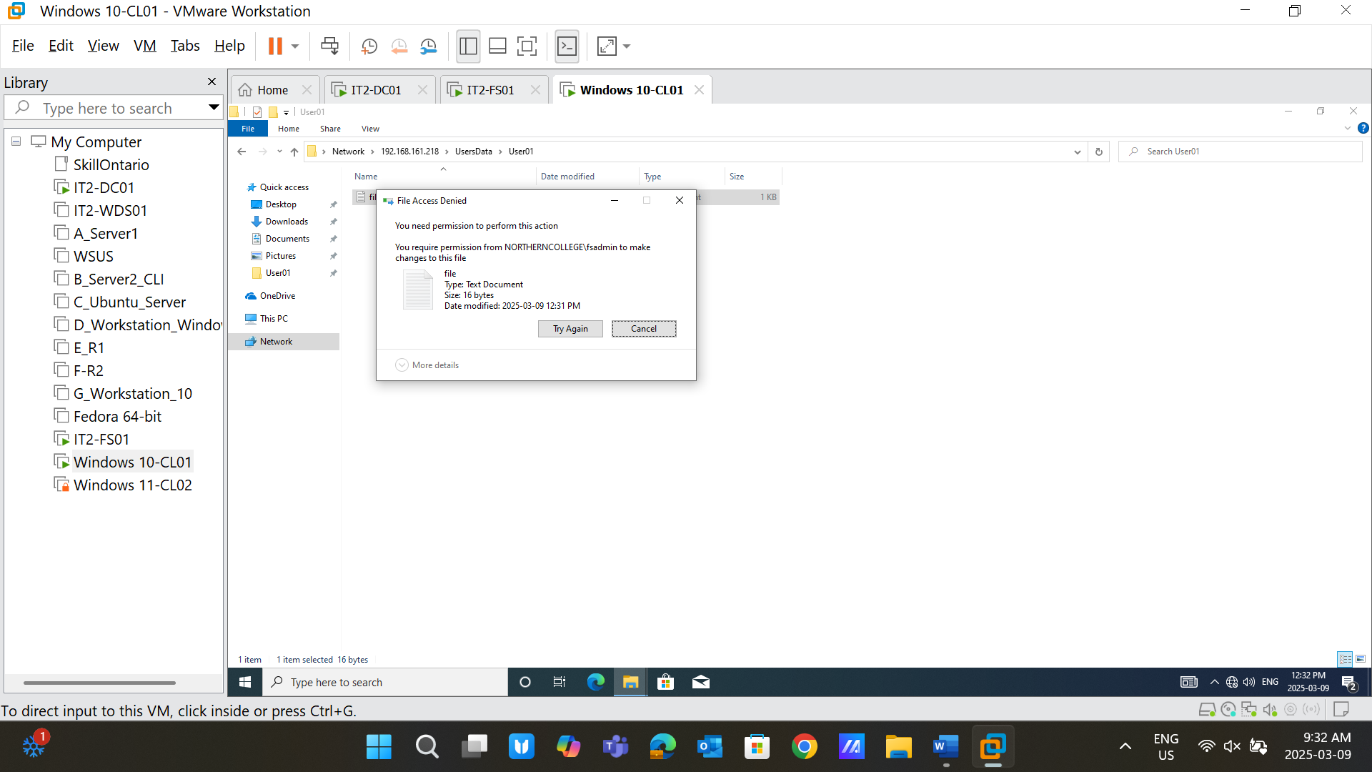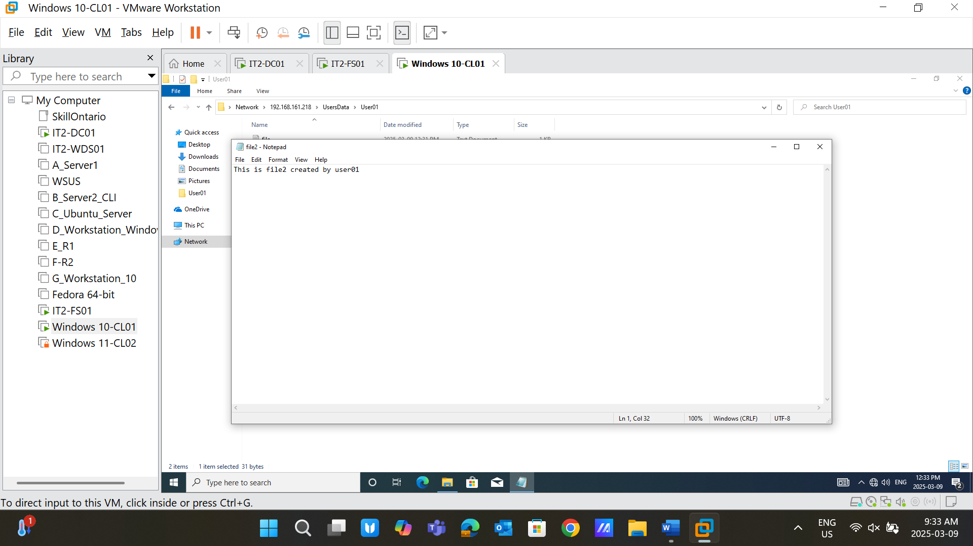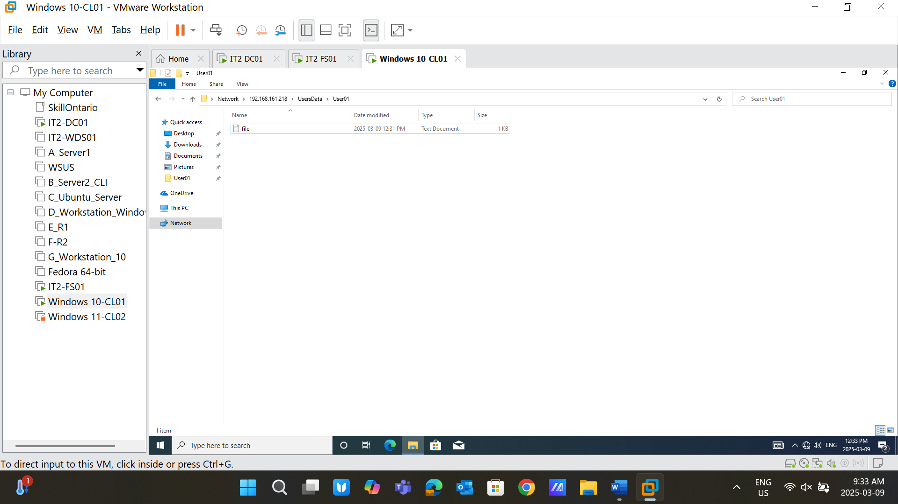

**User02: These five screenshots show when the user logged in to Windows11-CL02. User02 has modified permissions. So, he can read, write, and delete the file, as mentioned in the first three shots. Moreover, he could create a new file and then delete it which is shown by the next two screenshots.**